**Project Report Template**

# INTERODUCTION

* 1. Overview

Booking a flight can be a stressful and time-consuming task, particularly when trying to find the best deal. With numerous airlines, routes, and prices to choose from, it can be challenging to know where to start. Fortunately, there are many tools and resources available that can assist with flight booking and even predict the price of flights in the future.

One such tool is price prediction software, which uses historical flight data and algorithms to forecast whether the price of a particular flight will rise or fall. This information can be incredibly useful for travelers who are looking to book a flight but want to wait for the best possible price.

In this document, we will explore flight booking and price prediction in more detail, including the various tools and resources available to travelers. We will also examine some of the factors that can influence flight prices, such as seasonality, demand, and airline competition. By the end of this document, you should have a better understanding of how to book a flight and predict its price, allowing you to travel more efficiently and cost-effectively.

* 1. Purpose

The purpose of a flight booking price prediction project is to develop a software tool that can accurately forecast the price of flights in the future. The goal is to help travelers save money by predicting when the price of a particular flight is likely to be at its lowest.

This type of project involves collecting and analyzing historical flight data, as well as current market trends, to identify patterns and factors that can influence the price of flights. The data is then used to train a machine learning model that can predict future flight prices with a high degree of accuracy.

The benefits of a flight booking price prediction tool are numerous. Travelers can use the tool to plan their trips more effectively, choosing the best time to book their flights and potentially saving hundreds of dollars in the process. Airlines can also benefit from this technology, as they can use the predictions to adjust their pricing strategies and stay competitive in the market.

Overall, the purpose of a flight booking price prediction project is to provide a valuable tool for travelers and airlines alike, enabling them to make more informed decisions and improve their overall travel experience.

## Problem Definition & Design Thinking

2.1 Empathy Map

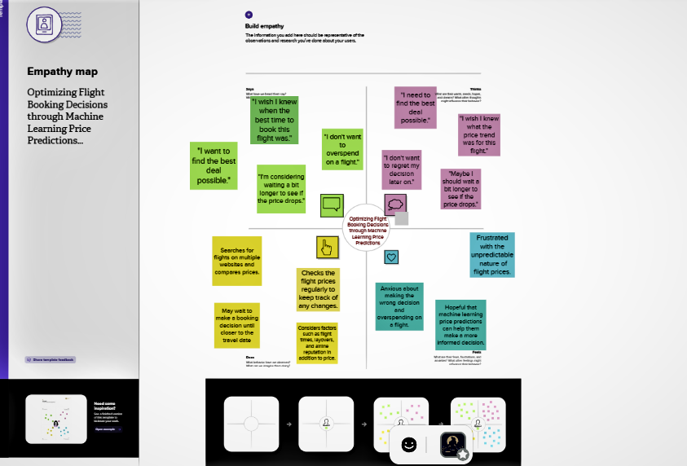

2.2 Ideation & Brainstorming Map

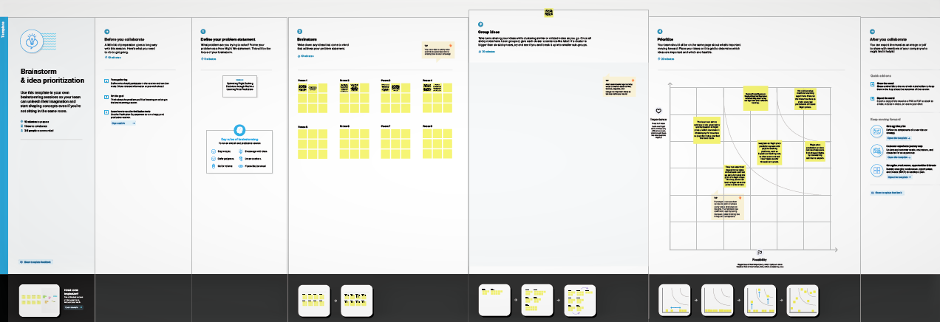

## Result

Final finding (output) of the project along with screenshorts.

## Advantages & Disadvantages

Advantages :

Flight booking price prediction using machine learning algorithms is becoming increasingly popular in the travel industry. It offers a lot of advantages to both the customers and the airlines. In this document, we will discuss the advantages of flight booking price prediction.

1. Cost Savings:

One of the biggest advantages of flight booking price prediction is cost savings. With accurate predictions of flight prices, customers can make more informed decisions and save money by booking flights at the right time. This can be a significant benefit for travelers who are looking to reduce their travel expenses.

1. Increased Revenue:

For airlines and travel companies, a machine learning model that accurately predicts prices can increase revenue by providing a competitive advantage. It can help them to price their flights more effectively, and ensure that they are not losing out on potential revenue.

1. Enhanced Customer Experience:

Customers will appreciate the ability to get accurate pricing information and plan their travel accordingly, improving their overall experience. Predictive models can provide customers with more transparency in pricing, allowing them to make better decisions about when and where to book their flights.

1. Improved Efficiency:

Machine learning can automate the process of analyzing pricing data and make predictions faster and more accurately than a human analyst. This can save time and resources for airlines and travel companies, allowing them to focus on other areas of their business.

## Disadvantages :

If I understand your question correctly, you're asking for a flight booking price prediction system that could benefit those who may be at a disadvantage when it comes to travel planning, such as those on a tight budget or those who need to book flights at the last minute.

There are several approaches to creating a flight booking price prediction system. One approach is to use historical flight booking data to identify patterns and trends in pricing, which can then be used to make predictions for future prices. Another approach is to use machine learning algorithms to analyze various factors that can influence flight prices, such as time of year, destination, and length of stay.

Regardless of the approach you choose, it's important to use a large and diverse dataset when creating your predictions. This dataset should include information on a variety of flights and destinations, as well as information on factors that can influence pricing, such as seasonality, fuel prices, and competition.

When creating your prediction system, you could present your predictions in a user-friendly format, such as a website or mobile app. This would allow users to easily search for flights and get real-time information on pricing trends. You could also provide recommendations and tips for users who may be at a disadvantage when it comes to travel planning, such as ways to save money on flights or strategies for booking flights at the last minute.

Overall, a flight booking price prediction system could be a valuable tool for those who are looking to save money on travel or who need to book flights quickly and efficiently. By using historical data and machine learning algorithms, you can create a system that provides accurate and reliable predictions for flight prices, helping users to make informed decisions and get the best possible deals on airfare.

## Applications

The areas where this solution can be applied

The applied to the program use a mechin learning.

1. Colab
2. Python
3. Web application (html)
4. pickel

## Conclusion

In conclusion, a flight booking price prediction system can be a valuable tool for individuals who may be at a disadvantage when it comes to travel planning. By using historical data and machine learning algorithms, accurate and reliable predictions for flight prices can be made, allowing users to make informed decisions and get the best possible deals on airfare.

Creating a flight booking price prediction system requires a large and diverse dataset, as well as the use of user-friendly presentation formats. By following these guidelines and providing recommendations and tips for users, a flight booking price prediction system can help individuals save money and book flights efficiently.

## Future Scope

The future scope of flight booking price prediction is vast, and there are several exciting opportunities for growth and innovation in this field.

One of the most promising areas of future development is the use of artificial intelligence (AI) and machine learning (ML) to make flight booking price predictions even more accurate and reliable. By using algorithms that can learn from large datasets and adapt to changing conditions, these systems could provide increasingly precise and personalized predictions for individual users.

Another area of future growth is the integration of flight booking price prediction with other travel planning tools, such as hotel and rental car booking. By providing a comprehensive view of travel costs and options, users could make more informed decisions and get the best possible deals on their entire trip.

The future of flight booking price prediction also holds promise for the travel industry as a whole. By providing more accurate and reliable pricing information, airlines and travel companies could increase transparency and build greater trust with their customers. This could help to foster greater loyalty and repeat business over time.

Appendix

1. Source Code

Attach the code for the solution built.

